Pi1541 – Rotary Encoder Board Rev. 0

Functional Description

The rotary encoder RT1 issues two square wave signals on channel A and channel B, depending on the direction of the turn, channel A is ahead of channel B or vice versa.

Since the rotary encoder is working mechanically, the two channels are required to be “debounced”. R6/R8/C6 or R5/R7/C7 are serving this purpose, as recommended by the manufacturer of the rotary encoder.

There are two identical circuits for the direction recognition, which consist of a D-flip flop and a mono-flop each. For both directions, channel A and Channel B play an opposite role.

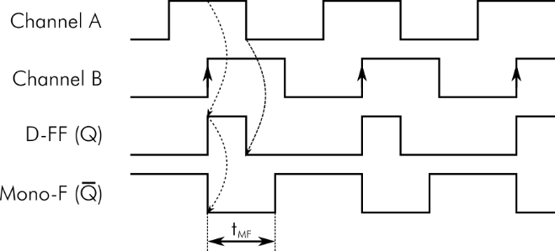

Figure 1: Channel A ahead of channel B

The case shown in Figure 1 describes a turn fitting the detected direction. Here, channel B is driving the clock signal of the D-flipflop (IC1), while channel A is connected to the D-input and the /CLR-signal of that D-FF. A rising edge of channel B will latch the level of channel A (in this case a HIGH) to the output Q. Later in the signal cycle, channel A will get LOW, which resets the D-FF via the /CLR input. The positive pulse generated on the output Q triggers the following mono-flop (IC2). This way, a LOW pulse of a duration tMF will be issued on the /Q output of IC2. tMF is determined by the R/C combination (R3 and C3 or R4 and C4) connected to the mono-flop.

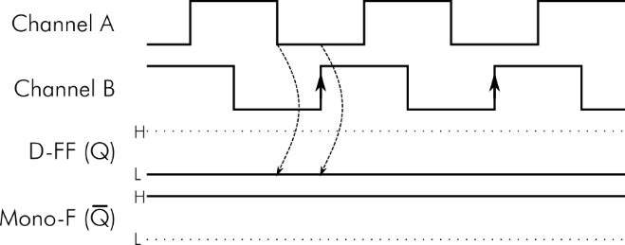

Figure 2: Channel B ahead of channel A

Turning the rotary encoder opposite to the detected direction will result in output signals shown in Figure 2. A LOW level of channel A will reset the D-FF. The output Q of IC1 will be reset. When the rising edge of Channel B latches the level of channel A, which is LOW at that time. The output Q of the D-FF will remain low. No pulses are generated by the mono-flop (IC2).

Pushing the rotary encoder will work as the Select/Reset switch. Pushing SW4 will exit the folder, SW5 will select the disk images for a multi disk game/demo.